About yourself

In a short paragraph, please tell us about yourself (you may wish to talk about; your interests, what pronoun you’d like to be referred to as, the nationality you identify with, family, gender)
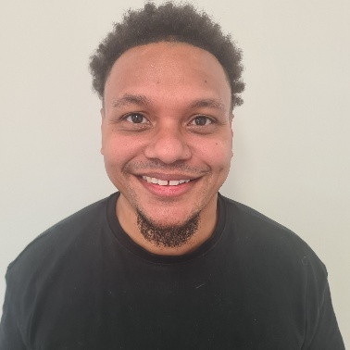

I am originally from south London. I’m of mixed heritage my dad is from Jamaica and my mum is half English and half Maltese. I love the Jamaican culture and especially Jamaican food. I am a big Arsenal fan.
I like to cook and try different foods from around the world.
My favourite thing to do is spend time with my fiancé and children.
To wind down I love going to the gym and playing my PlayStation.
I’m obsessed with trainers and have a huge collection.
I love to make people laugh and don’t like to take myself too seriously.

